BSCS FINAL PROJECT

Software Design Specification

SportWearXpress



Project Advisor

**Anum Mustaqeem**

Presented by:

**Group ID: F24SE002**

**L1S21BSSE0072** **M Awais Akram**

**L1F21BSSE0564 Muahammad Muneeb Butt**

**L1F21BSSE0476 Muahammad Qasim Abbas**

**Faculty of Information Technology**

**University of Central Punjab**

Software Design Specification

SDP Phase II

SportsWearXpress

Advisor: Anum Mustaqeem

F24SE002

|  |  |
| --- | --- |
| Member Name | Primary Responsibility |
| M Awais Akram | 1,2,3,4 |
| Muhammad Muneeb Butt | 1,2,3,4 |
| Muhammad Qasim Abbas | 1,2,3,4 |

Table of Contents

Table of Contents i

Revision History ii

Abstract iii

1. Introduction 1

1.1 Product 1

1.2 Background 1

1.3 Objective(s)/Aim(s)/Target(s) 1

1.4 Scope 1

1.5 Business Goals 1

1.6 Document Conventions 1

1.7 Miscellaneous 1

2. Overall Description 2

2.1 Product Features 2

2.2 Functional Description 2

2.3 User Classes and Characteristics 2

2.4 Design and Implementation Constraints 2

2.5 Assumptions and Dependencies 2

3. Technical Architecture 3

3.1 Application and Data Architecture 3

3.2 Component Interactions and Collaborations 3

3.3 Design Reuse and Design Patterns 4

3.4 Technology Architecture 4

4. Screenshots/Prototype 5

4.1 Workflow 5

4.2 Screens 5

4.3 Additional Information 5

5. Other Design Details 5

6. Revised Project Plan 5

7. References 5

Appendix A: Glossary 6

Appendix B: IV & V Report 7

Revision History

|  |  |  |  |
| --- | --- | --- | --- |
| **Name** | **Date** | **Reason For Changes** | **Version** |
|  |  |  |  |
|  |  |  |  |

# Abstract

The **SportswearXpress** project aims to address the challenges of personalized sportswear customization through an AI-enhanced e-commerce platform. Current solutions lack advanced tools for design precision, real-time communication, and dynamic pricing, leading to inefficiencies, miscommunication, and unmet customer expectations. This project is significant as it provides a streamlined, efficient approach to customization, improving both user satisfaction and seller operations.

The platform integrates AI-powered design tools to guide users step-by-step in creating custom designs, ensuring accuracy and reducing errors. Real-time communication features bridge the gap between customers and sellers, enabling seamless collaboration. A dynamic pricing algorithm calculates costs based on design complexity and tool usage, ensuring fair and transparent pricing.

Key knowledge areas include artificial intelligence for personalized design assistance, real-time communication systems for interaction, and database management for handling user data and transactions. The results of this project include a scalable, browser-based solution that optimizes the customization process, enhances user engagement, and sets a new standard for the sportswear industry.

# Introduction

## Product

SportswearXpress is an AI-powered e-commerce platform designed to solve the challenges associated with customizing sportswear. Traditional customization systems lack intuitive design guidance, real- time communication, and transparent pricing, leading to unmet customer expectations and inefficiencies. SportswearXpress leverages AI to provide users with step-by-step design recommendations, dynamic pricing based on customization complexity, and seamless real-time communication with sellers. This solution aims to enhance user satisfaction and streamline the customization process, setting a new standard for personalized sportswear shopping.

## Background

The sportswear customization domain is rapidly evolving, driven by a growing demand for personalized products. However, current e-commerce platforms in this space often lack sophisticated design tools, dynamic pricing systems, and real-time communication features, resulting in customer dissatisfaction and operational inefficiencies. SportswearXpress aims to address these challenges by providing an AI-enhanced platform that allows for accurate and intuitive customization, improving customer experience and seller efficiency.

## Objective(s)/Aim(s)/Target(s)

The objectives of SportswearXpress are to:

* Develop an AI-driven platform for sportswear customization.
* Integrate AI tools to guide users in personalizing sportswear designs.
* Implement a dynamic pricing model based on design complexity.
* Enable real-time, seamless communication between users and sellers.
* Improve customer satisfaction and operational efficiency.

## Scope

The scope of SportswearXpress includes essential features aimed at enhancing the sportswear customization experience:

* User Customization Interface: A web platform for creating personalized sportswear designs with various options.
* AI-Powered Design Tools: Intelligent tools that guide users through the customization process.
* AI Chatbot: Real-time assistance and recommendations throughout the design journey.
* Dynamic Pricing Model: Automatic adjustments of prices based on customization complexity.
* Real-Time Communication: Direct interaction between customers and sellers for immediate support.
* User Account Management: Secure accounts for saving designs and tracking order history.
* Administrative Dashboard: Tools for sellers to manage products and analyze customer interactions.
* Testing and Deployment: Comprehensive testing before launch and ongoing maintenance for continuous improvement.

## Business Goals

SportswearXpress aims to achieve the following business objectives:

* Enhancing Customer Satisfaction: Elevate customer satisfaction by providing intuitive and precise customization options that cater to individual preferences.
* Minimizing Design Errors: Decrease design errors and miscommunication through the implementation of AI-driven guidance and real-time communication tools.
* Optimizing Operational Efficiency: Streamline operations by automating design assistance and dynamic pricing adjustments, allowing for a more efficient workflow.
* Setting Industry Standards: Establish a competitive benchmark in the sportswear sector by delivering innovative, AI-powered e-commerce solutions that redefine customer engagement.

## Document Conventions

This SRS follows the standard format for software requirements specifications. The document utilizes the following conventions: Font Styles: Section headings are in bold font of 14 **Times**, while subsection headings are in bold of size 12. Regular text is used for descriptions and content. Highlighting: Important terms or concepts may be highlighted using bold or italic font for emphasis. Numbering: Sections organization and reference purposes. and subsections are numbered sequentially Nomenclature: Where applicable, technical terms or acronyms are defined upon first use to ensure clarity and understanding throughout the document.

## Miscellaneous

1. **Team Roles and Responsibilities**  
   Clearly define roles for team members (if any), such as project manager, developer, tester, and designer, to ensure smooth collaboration and accountability.
2. **Technological Tools**  
   List all the tools and frameworks used in the project, such as:

* **Front-end Development**: React.js or Angular for building user interfaces.
* **Back-end Development**: Node.js, Django, or Java Spring Boot for server-side logic.
* **AI Tools**: TensorFlow, OpenCV, or other machine learning frameworks for implementing AI functionalities.
* **Database Management**: MySQL, MongoDB, or Firebase for storing data.
* **Version Control**: Git and GitHub for source code management.

1. **Project Timelines**  
   Define a high-level timeline for project milestones, such as requirement gathering, development, testing, and deployment phases.
2. **Contingency Plans**  
   Outline fallback mechanisms in case of system failures or delays. For example:

* Backup solutions for data.
* A plan to handle high traffic or server downtime.

1. **Training and User Guides**  
   Provide training resources and user manuals for:

* Admin users to manage the system (e.g., inventory updates, analytics reports).
* End users to navigate the product customization and order placement processes.

1. **Collaboration Tools**  
   Mention tools used for communication and collaboration, such as:

* Slack, Microsoft Teams, or Discord for team communication.
* Project management tools like Jira or Trello for task tracking.

1. **Future Enhancements**  
   Outline possible future updates, such as:

* Introducing new AI-powered features.
* Expanding to support other sportswear categories.
* Integrating augmented reality (AR) for product visualization.

# Overall Description

## Product Features

**AI-Powered Design Tools**: Intuitive tools guide users step-by-step through the customization process, ensuring precision and ease.

**Dynamic Pricing Model:** Automatic pricing adjustments based on the complexity of each design, ensuring transparency and fairness.

**Real-Time Communication:** Direct interaction between users and sellers to provide immediate support and clarify customization needs.

**User Customization Interface:** A user-friendly web platform with a wide array of customization options for personalized sportswear designs.

**AI Chatbot:** Provides real-time assistance and personalized recommendations throughout the design process.

**User Account Management:** Secure user accounts for saving designs and tracking order history.

**Administrative Dashboard:** Tools for sellers to manage products, track customer interactions, and analyze performance.

## Functional Description

The current system, **SportswearXpress**, is an AI-powered e-commerce platform aimed at revolutionizing the sportswear customization experience. Its key functionalities include:

1. **AI-Powered Design Tools**: Assists users in creating personalized sportswear with real-time, step-by-step design recommendations.
2. **Dynamic Pricing**: Automatically adjusts product prices based on customization complexity and selected features.
3. **Real-Time Communication**: Enables seamless interaction between customers and sellers for queries or design feedback.
4. **Customization Interface**: Provides a user-friendly platform for product design, including options like colors, text, and designs.
5. **User Account Management**: Allows users to create accounts, save designs, and track orders.
6. **Analytics and Reporting**: Offers administrators insights into user behavior, sales trends, and system performance.
7. **Order Tracking and Management**: Tracks orders from placement to delivery with options for cancellation and refund.
8. **Product Reviews and Ratings**: Enables users to leave feedback on purchased items.

The platform leverages technologies such as TensorFlow.js, OpenCV, and Socket.io for AI, image processing, and communication.

## User Classes and Characteristics

**1. Admin**

**Description:** This user class manages the overall operations and ensures the smooth functioning of the platform.

**Characteristics:**

Authority to manage users, products, and policies.

Handles complaints and generates analytics reports.

Enforces policies and suspends accounts if necessary.

**Priority:** High (essential for system governance).

**2. Buyer**

**Description:** The end user who purchases products, customizes designs, and places orders on the platform.

**Characteristics:**

Browses and customizes products.

Adds items to the cart and completes purchases.

Submits reviews and files complaints, if needed.

Uploads payment screenshots to confirm purchases.

**Priority:** High (primary user class).

**3. Seller**

**Description:** Individuals or businesses offering products for sale and managing product-related activities.

**Characteristics:**

Lists and updates products, including prices and stock quantities.

Manages orders, tracks payments, and initiates shipping.

Responds to messages, reviews, and complaints.

**Priority:** High (key stakeholders for platform operation).

**4. Messenger**

**Description:** Facilitates communication between buyers and sellers.

**Characteristics:**

Handles the exchange of messages regarding orders and product details.

Manages payment confirmations or other updates.

**Priority**: Medium (supports collaboration).

**5. Pricing Engine**

**Description:** Automates the calculation of product prices based on customization and other factors.

**Characteristics:**

Uses dynamic pricing models for fair pricing.

Interacts with buyers during the customization process.

**Priority:** Medium (enhances user experience).

**6. AI Chatbot**

**Description:** Provides AI-driven assistance for product customization and design suggestions.

**Characteristics:**

Offers design recommendations based on user input.

Interacts with the buyer during the product design process.

**Priority:** Medium (improves usability and engagement).

## Design and Implementation Constraints

1. **Specific Technologies, Tools, and Databases:**  
   • Utilizing technologies like TensorFlow.js, OpenCV, and Socket.io limits the choice of programming languages and development frameworks.  
   • Databases must support rapid data retrieval and real-time updates, influencing the choice of database management systems.
2. **Parallel Operations:**  
   • The platform must support simultaneous user interactions and real-time updates, requiring robust concurrency management.  
   • Parallel operations may necessitate load balancing and efficient resource allocation to maintain performance.
3. **Communications Protocols:**  
   • Realtime communication features depend on reliable and secure protocols to ensure seamless interaction between users and sellers.
4. **Design Conventions or Programming Standards:**  
   • Adhering to standard design conventions and programming best practices to ensure maintainability and scalability.  
   • Using a modular design approach to facilitate future enhancements and integrations.

## Assumptions and Dependencies

## Technical Architecture

**Architecture Diagram for complete system**

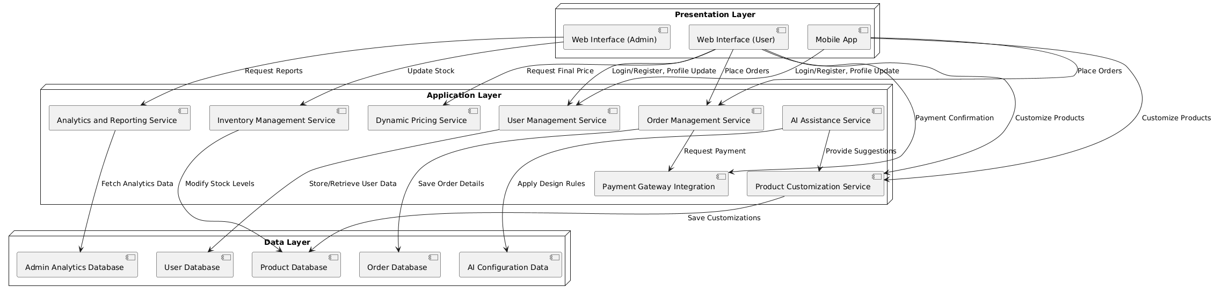

## 3.1 Application and Data Architecture

**Component Diagram**

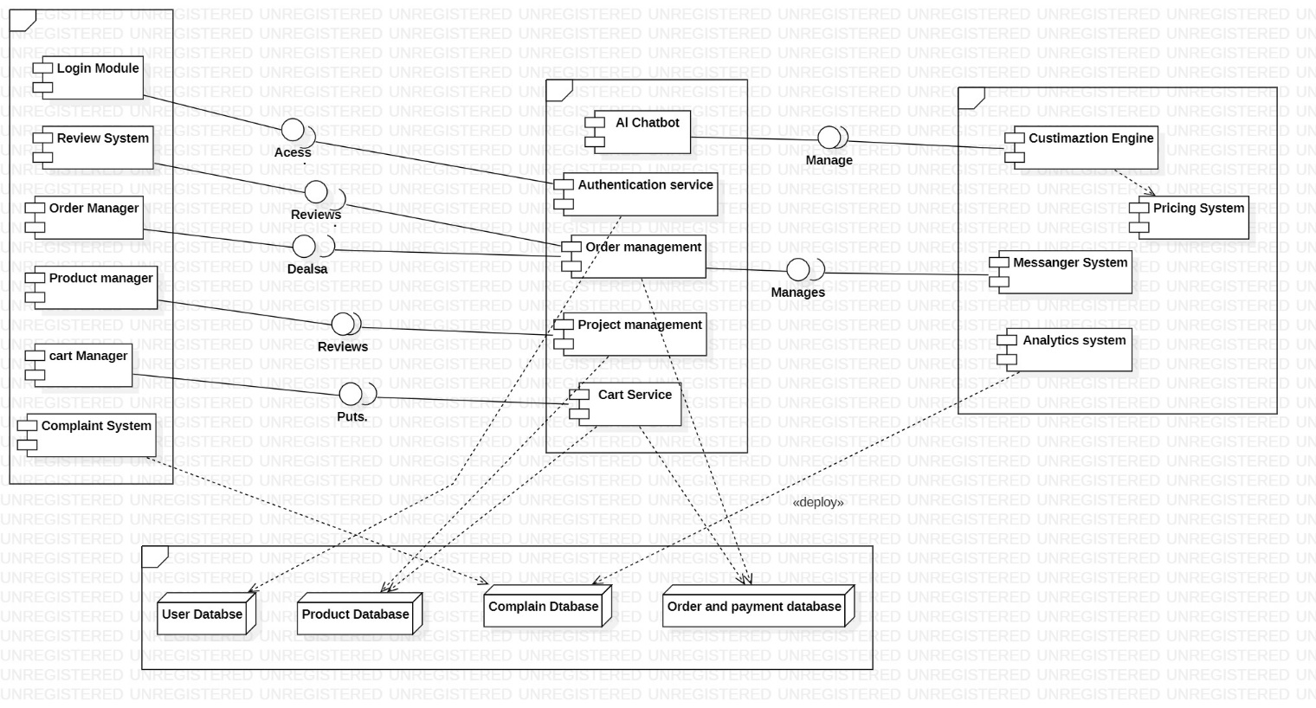

**ERD Diagram**

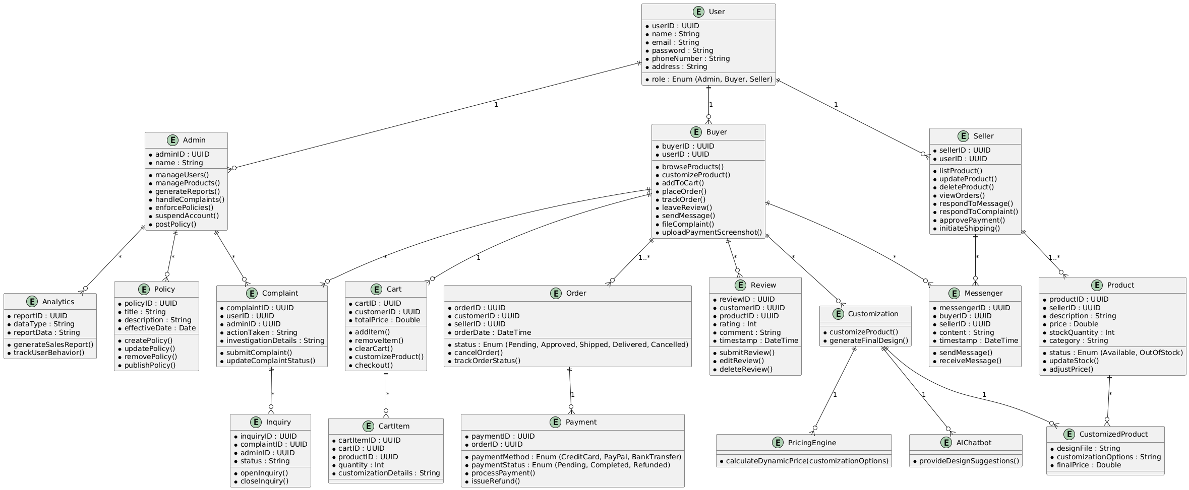

**Class Diagram**

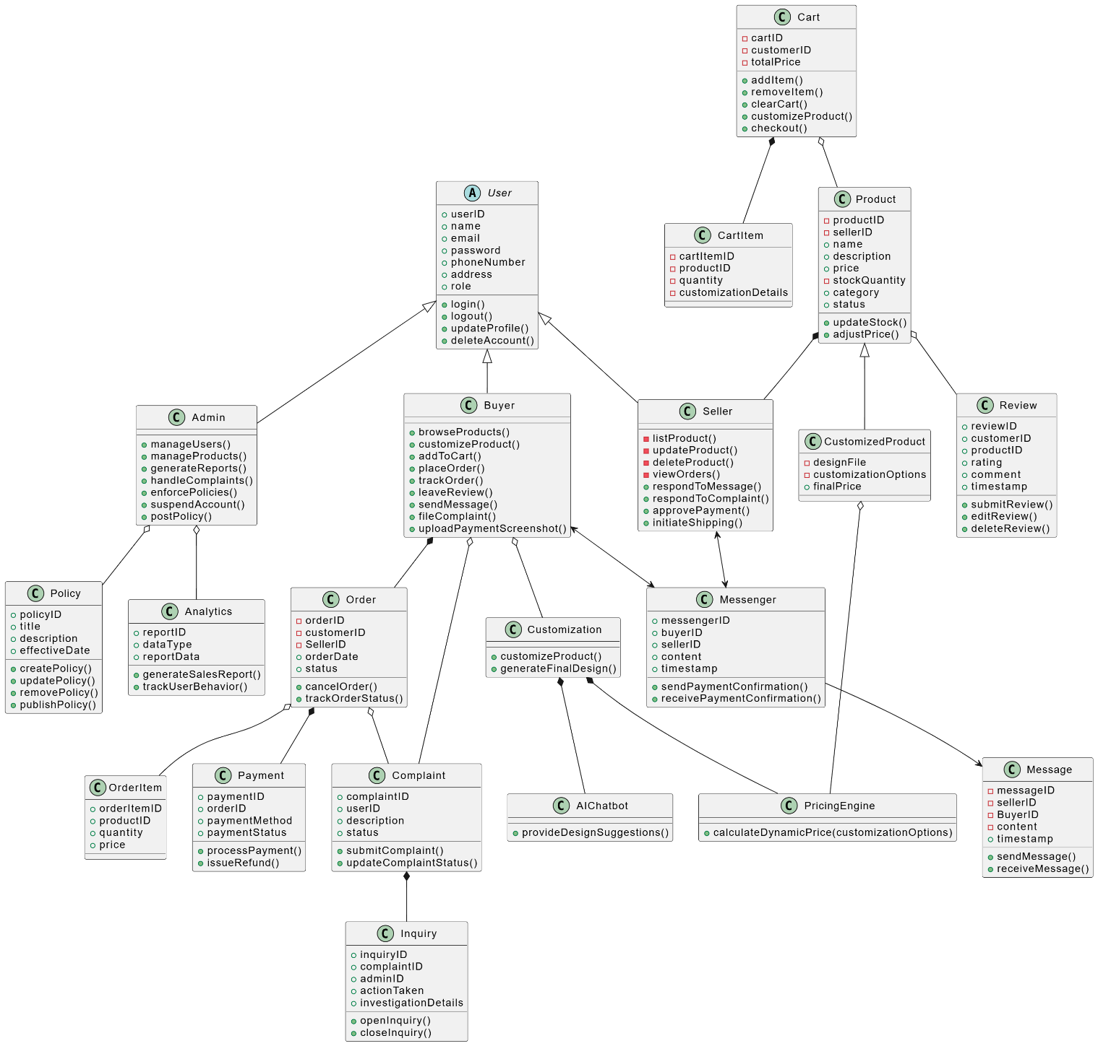

**Activity Diagram of Whole System**

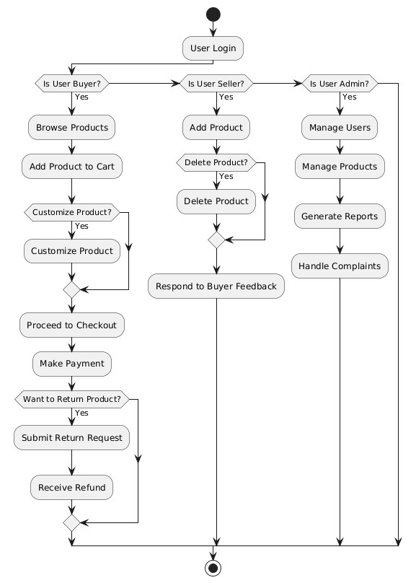

**Decision Table**

|  |  |  |  |  |
| --- | --- | --- | --- | --- |
| **Condition** | **Rule 1** | **Rule 2** | **Rule 3** | **Rule 4** |
| User logged in | Yes | No | Yes | No |
| Item in stock | Yes | Yes | No | Yes |
| Payment details valid | Yes | Yes | Yes | No |

|  |  |  |  |  |
| --- | --- | --- | --- | --- |
| **Action** | **Rule 1** | **Rule 2** | **Rule 3** | **Rule 4** |
| Add to cart | Yes | No | No | No |
| Display "Out of stock" | No | No | Yes | No |
| Prompt payment validation | No | No | No | Yes |
| Complete order | Yes | No | No | No |

## 3.2 Component Interactions and Collaborations

**Event Traces**

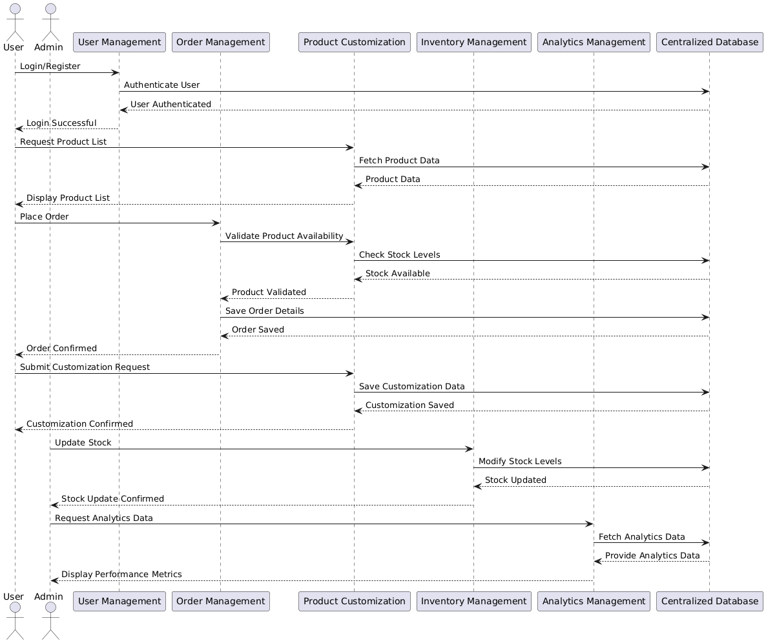

**DFD Level-0**

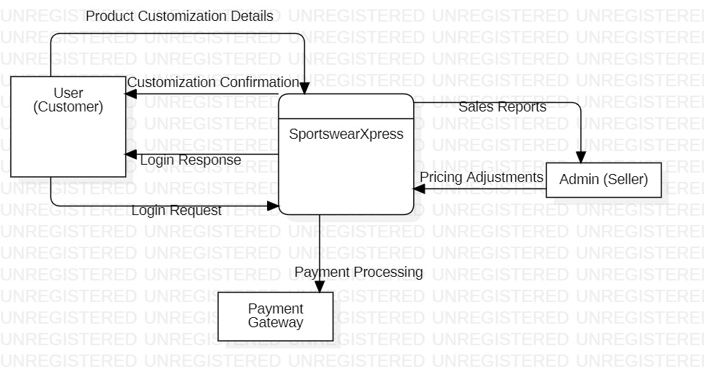 DFD Level-1

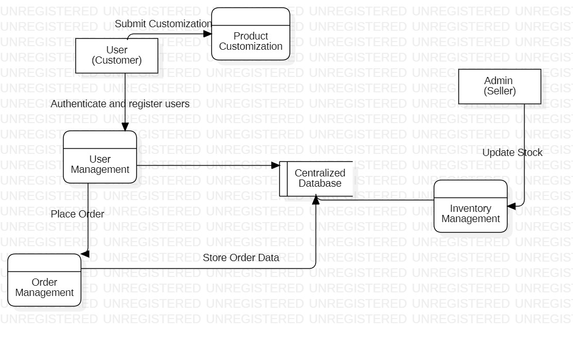

**DFD Level-2**

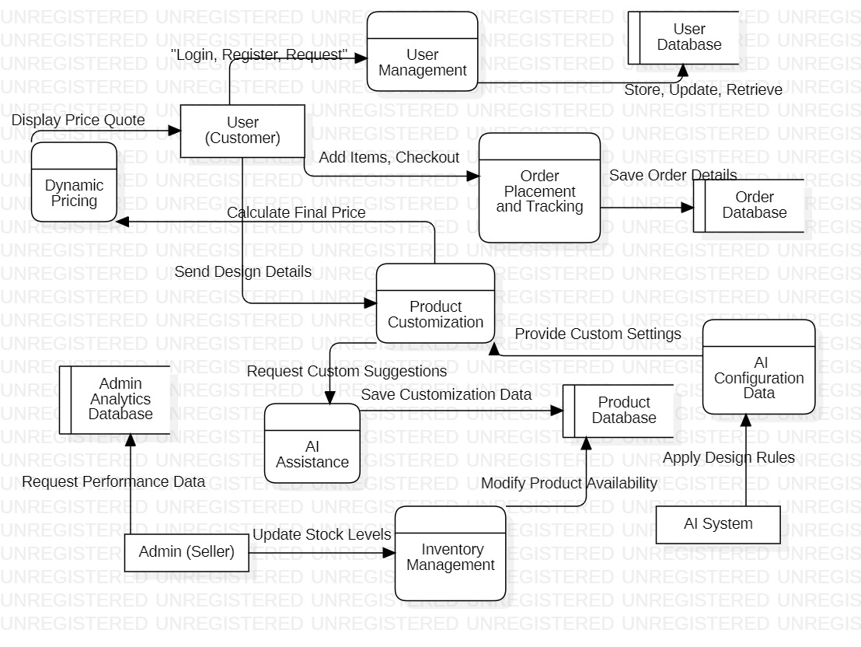

**Sequence Diagram for Seller**

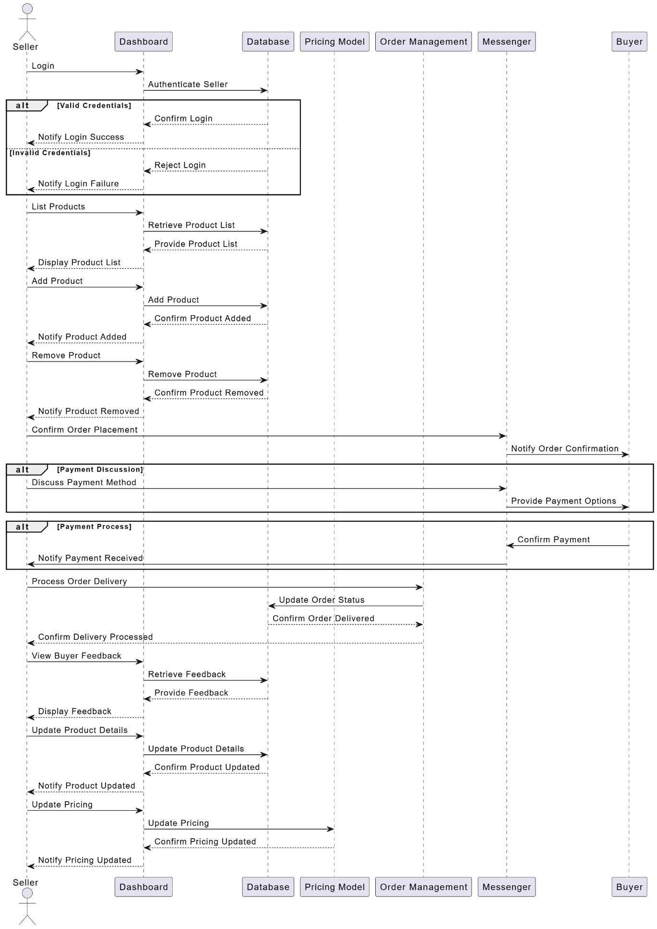

**Sequence Diagram of Admin**

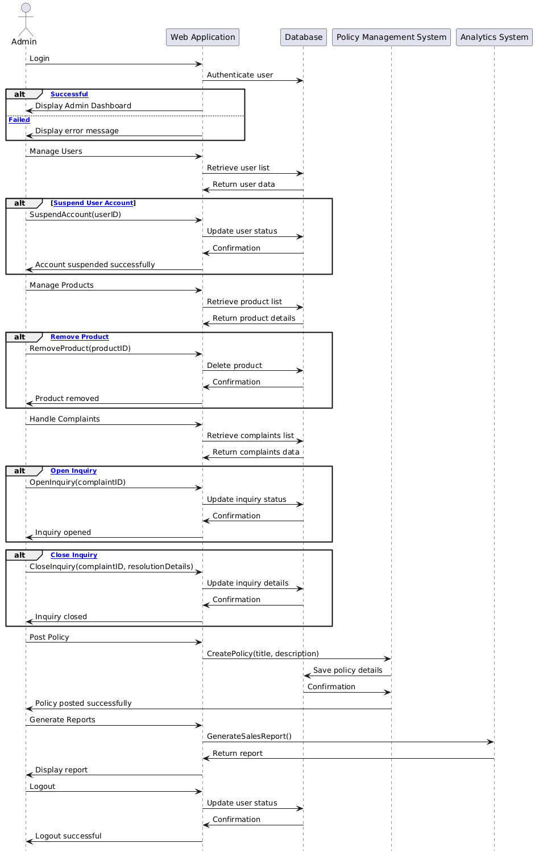

**Sequence Diagram for Buyer**

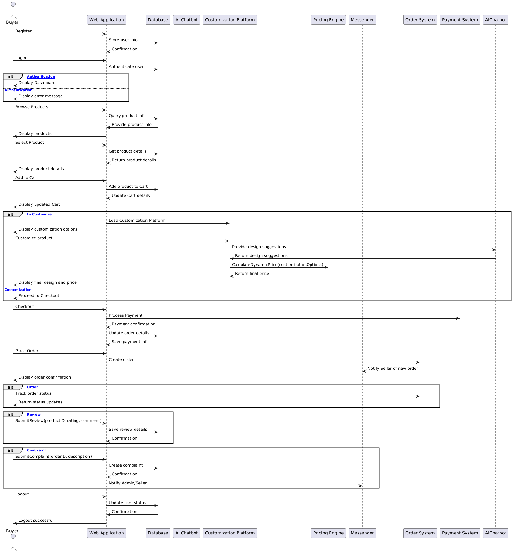

**Sequence Diagram order cancellation**

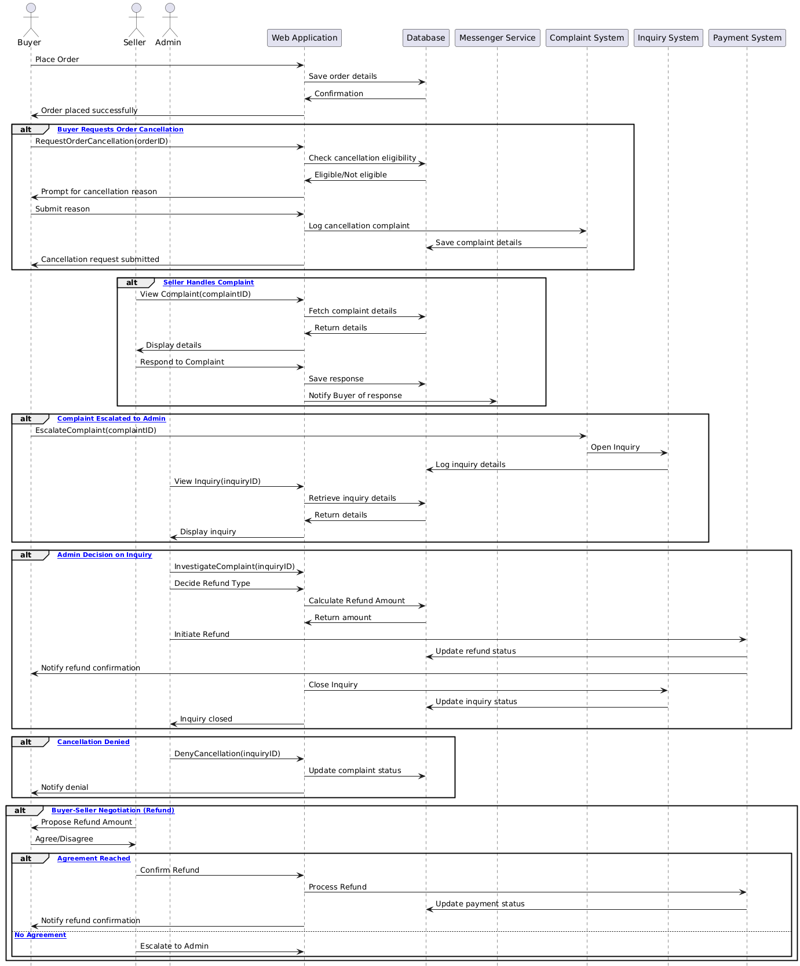

## 3.3 Design Reuse and Design Patterns

During the development of SportswearXpress, design reuse and patterns were used for efficiency and scalability:

**1. Design Reuse**

Reusable Components: UI elements (buttons, forms) and order processing logic (adding to cart, checkout) are reused across different modules like profile management and order tracking.

Codebase Reuse: Common utility functions for validation and formatting, along with third-party libraries like TensorFlow.js (AI) and Socket.io (real-time communication), were reused.

## 3.4 Technology Architecture

The **SportswearXpress** platform’s technology architecture is designed for scalability, performance, and security.

#### ****1. Platform****

* **Frontend:** Built using **React.js**, **HTML5**, **CSS3**, and **JavaScript** for a responsive and interactive UI on both **desktop** and **mobile**.
* **Backend:** Powered by **Node.js** with **Express.js** and **MongoDB** for data storage.

#### ****2. System Hosting****

* Hosted on **cloud platforms** like **AWS** or **Google Cloud** for scalability and high availability.

#### ****3. Connectivity Requirements****

* **Internet Connectivity:** Stable internet is essential for real-time features like messaging and order tracking.
* **API Integrations:** Includes payment processing (**Stripe**, **PayPal**), messaging (**Socket.io**), and AI (**TensorFlow.js**).

#### ****4. Modes of Operations****

* **Real-time Communication:** Uses **WebSockets** for instant messaging.
* **AI Customization:** In-browser AI via **TensorFlow.js** for seamless design suggestions.

#### ****5. Security****

* **Encryption:** **SSL/TLS** encryption for secure communication.
* **Authentication:** **OAuth 2.0** for secure user access.

# Screenshots/Prototype

## 4.1 Workflow



## Screens

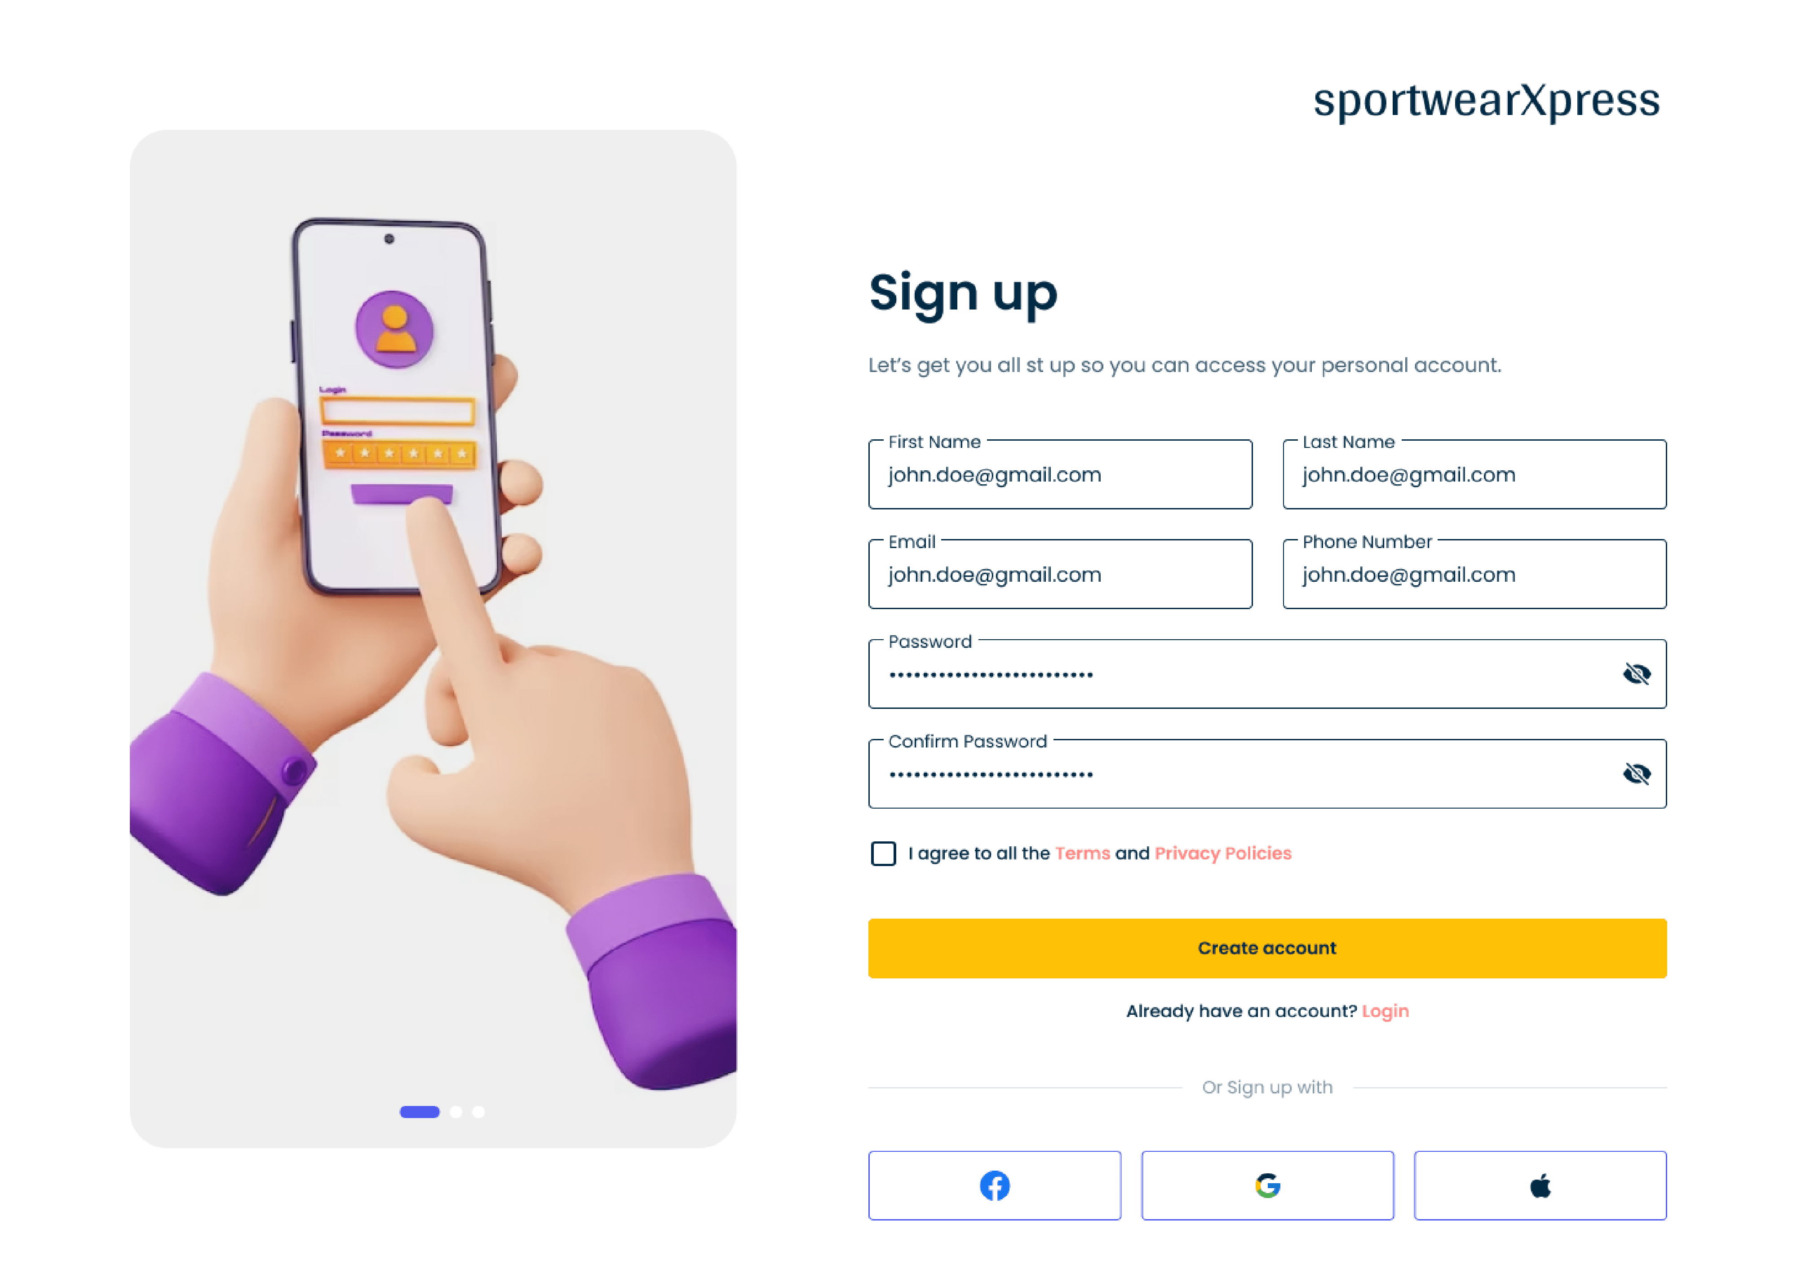

Screen #1: Sign Up

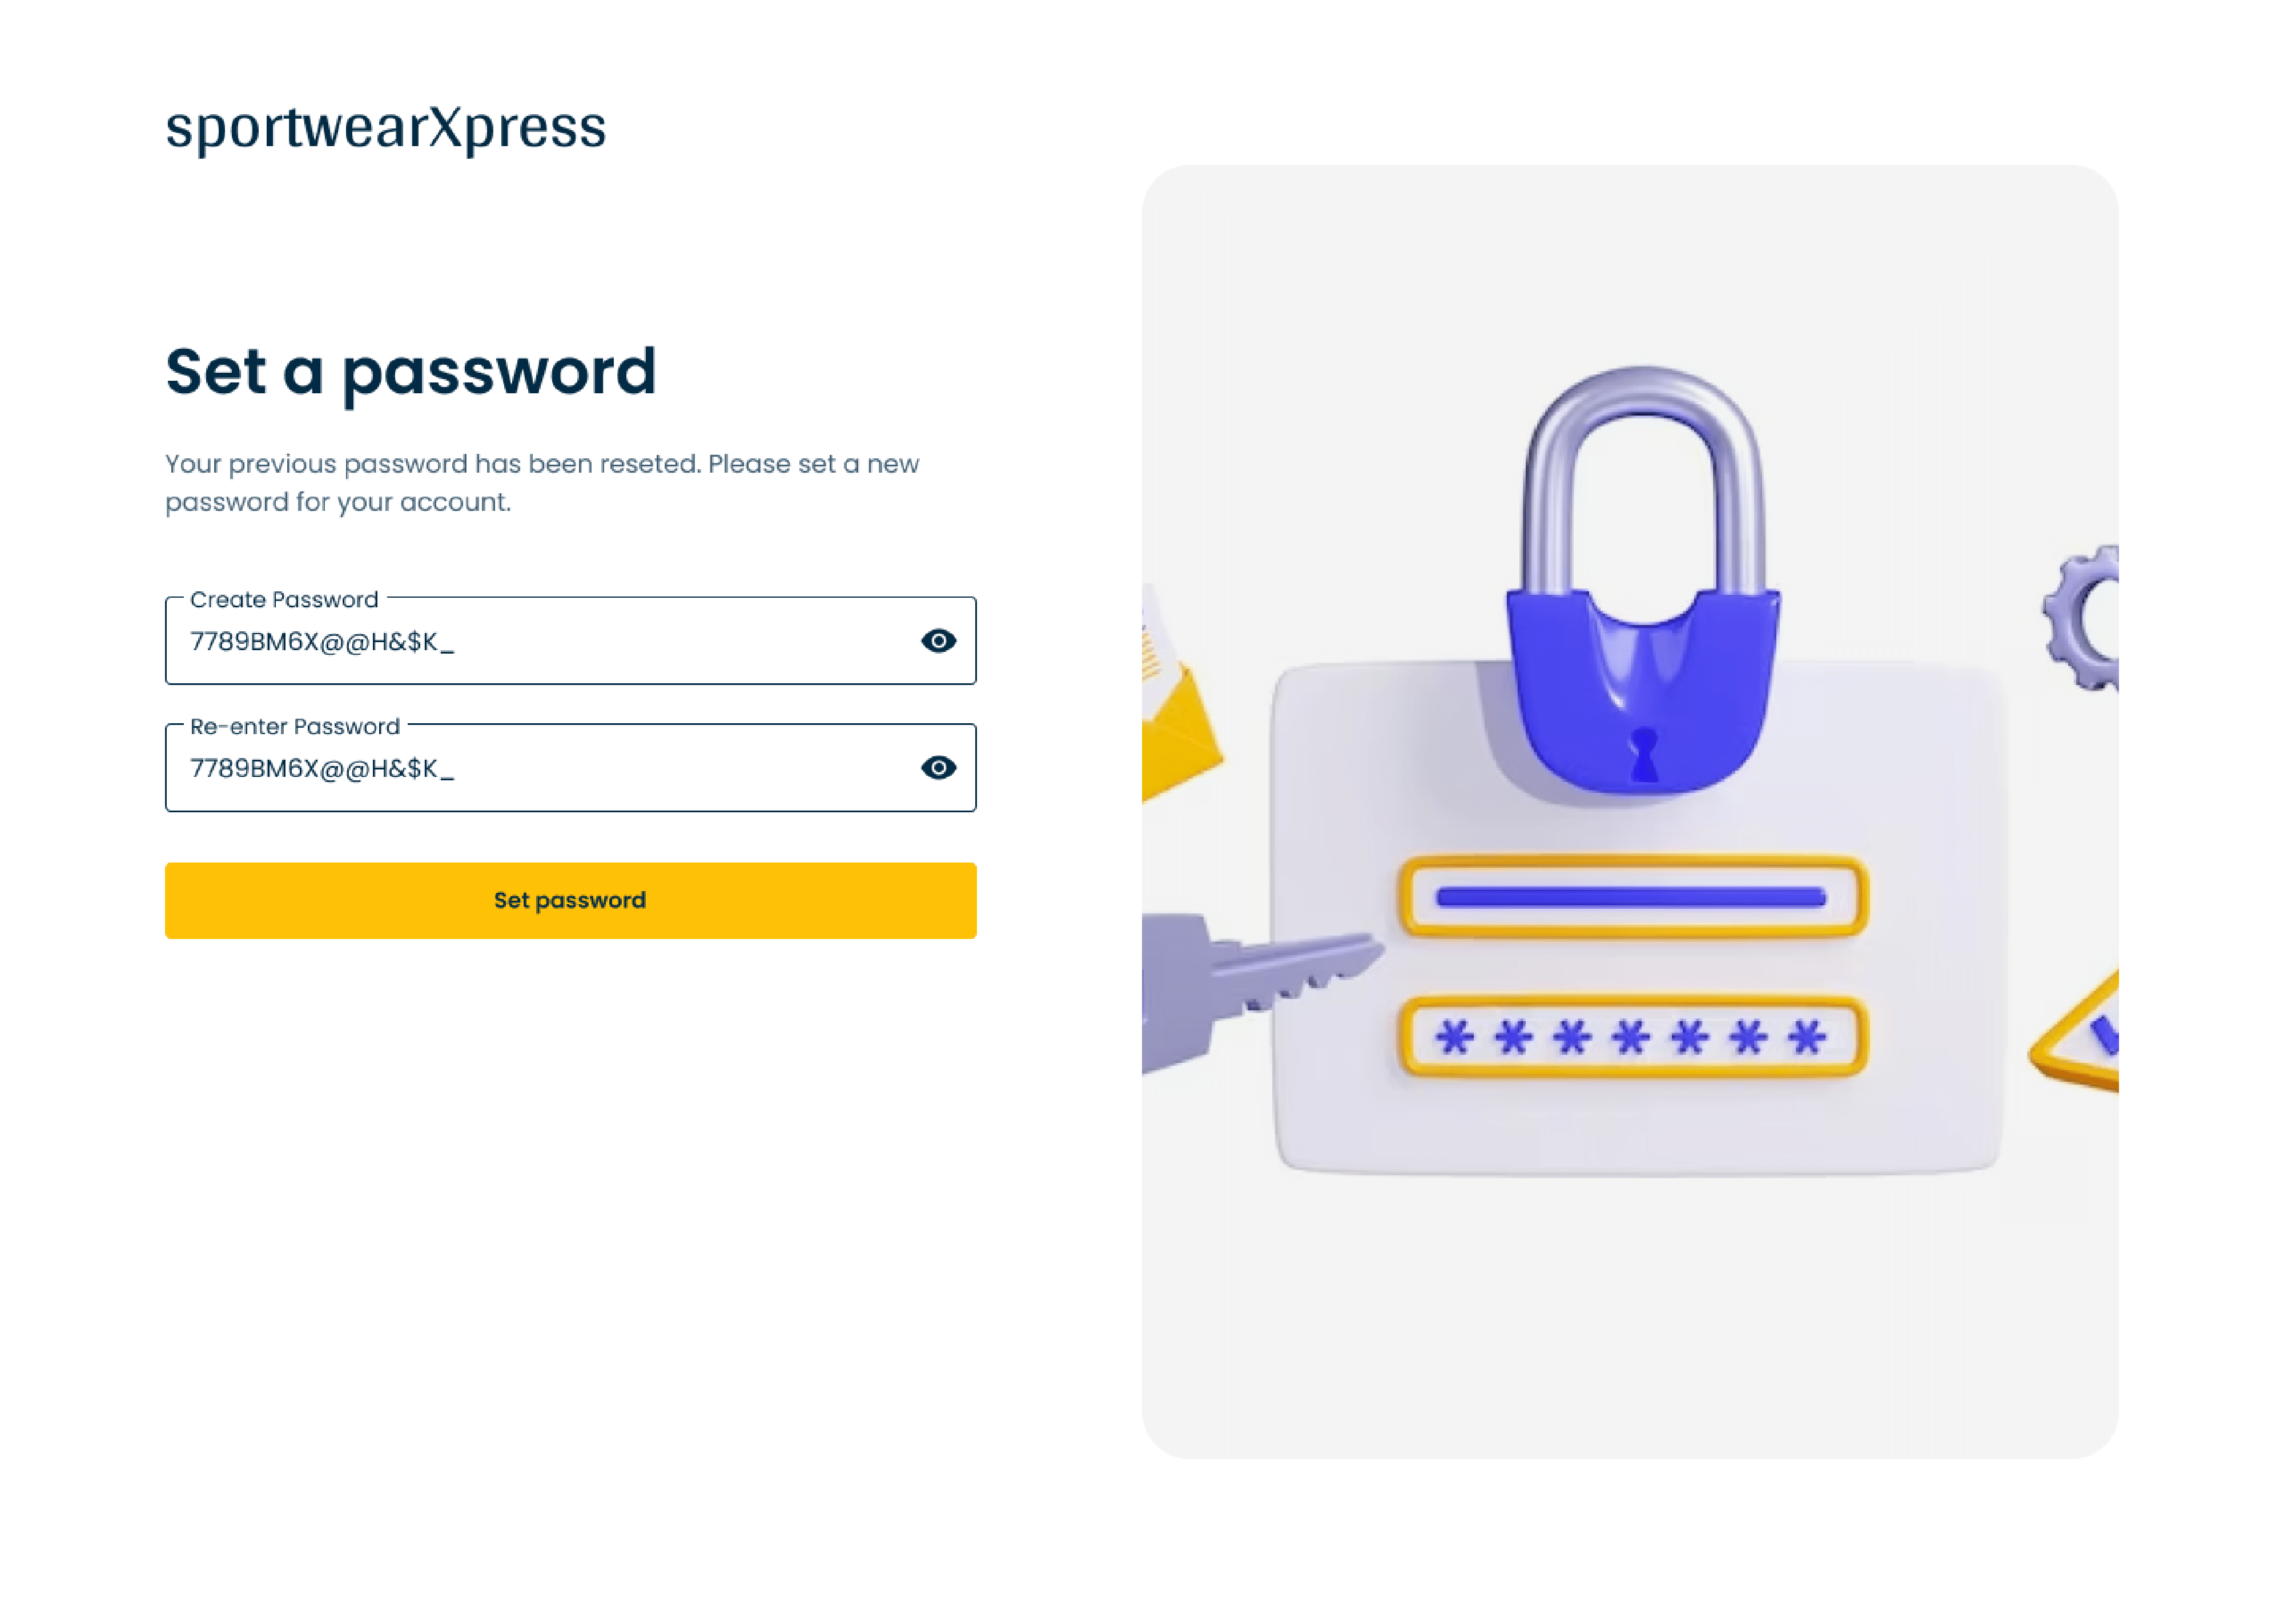

Screen #2: Set Password

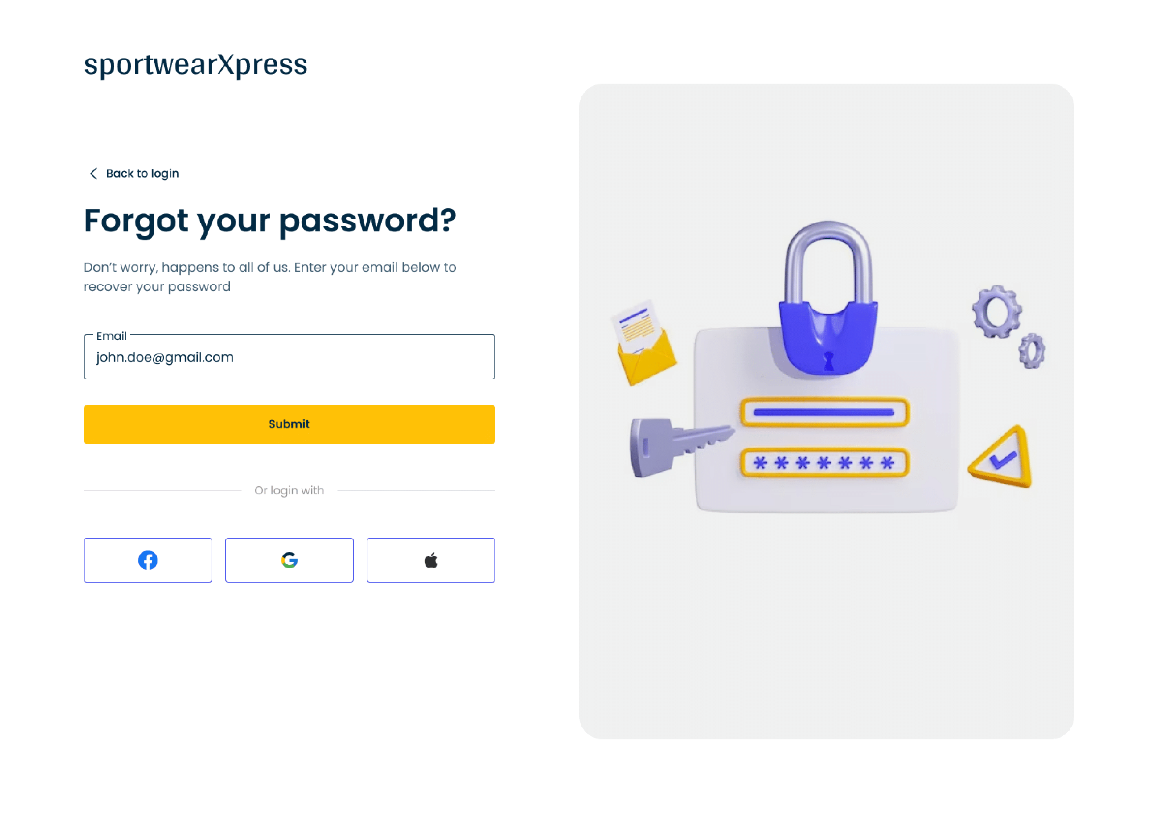

Screen #3: Forget your Password

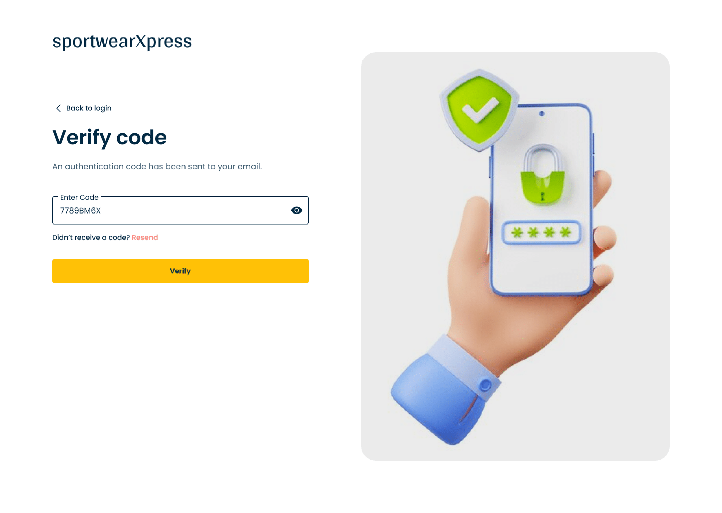

Screen #4: Verify Code

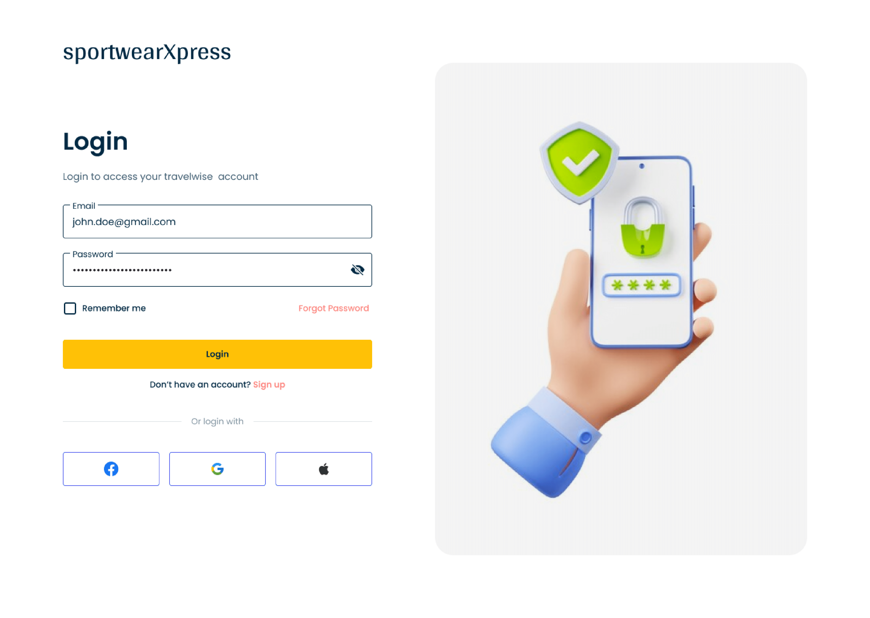

Screen #5: Login In

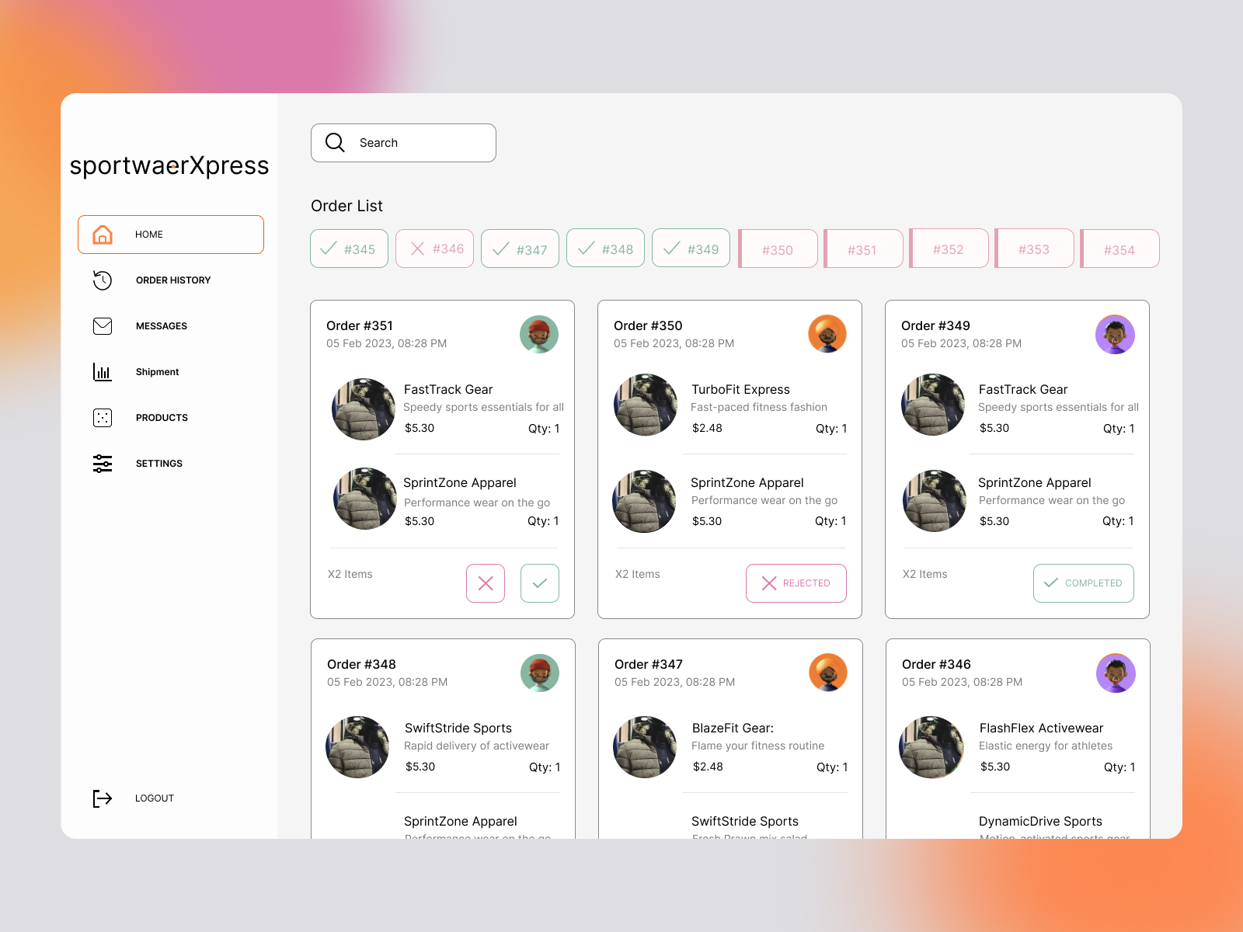

Screen #6: Order list

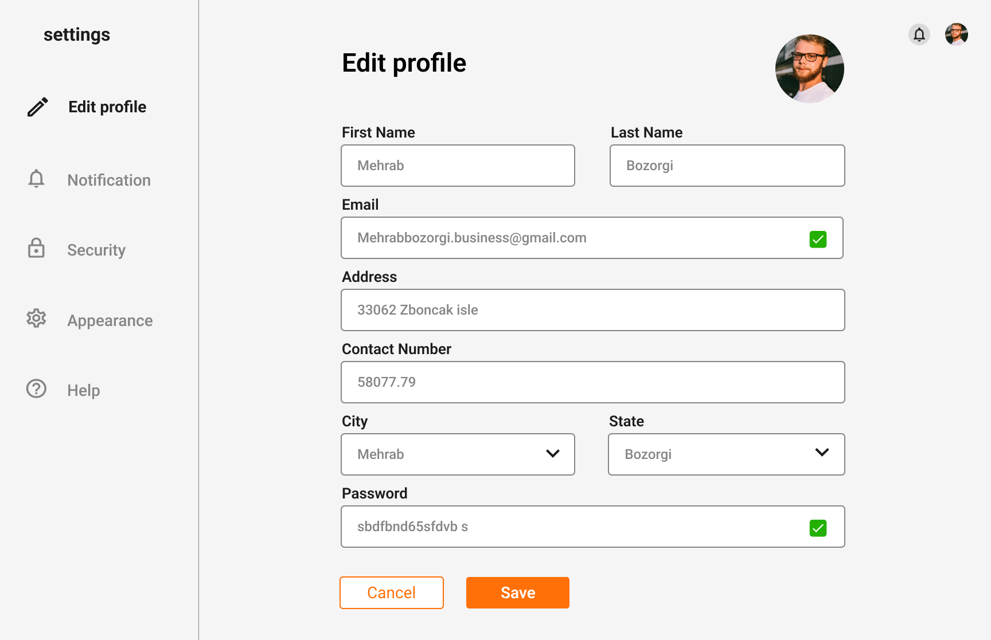

Screen #7: Edit Profile

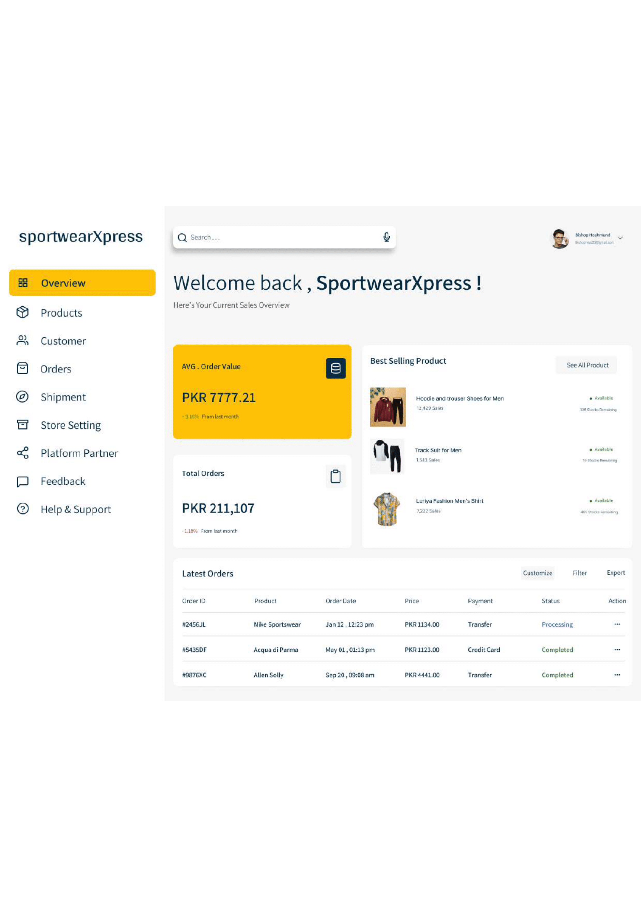

Screen #8: Dashboard

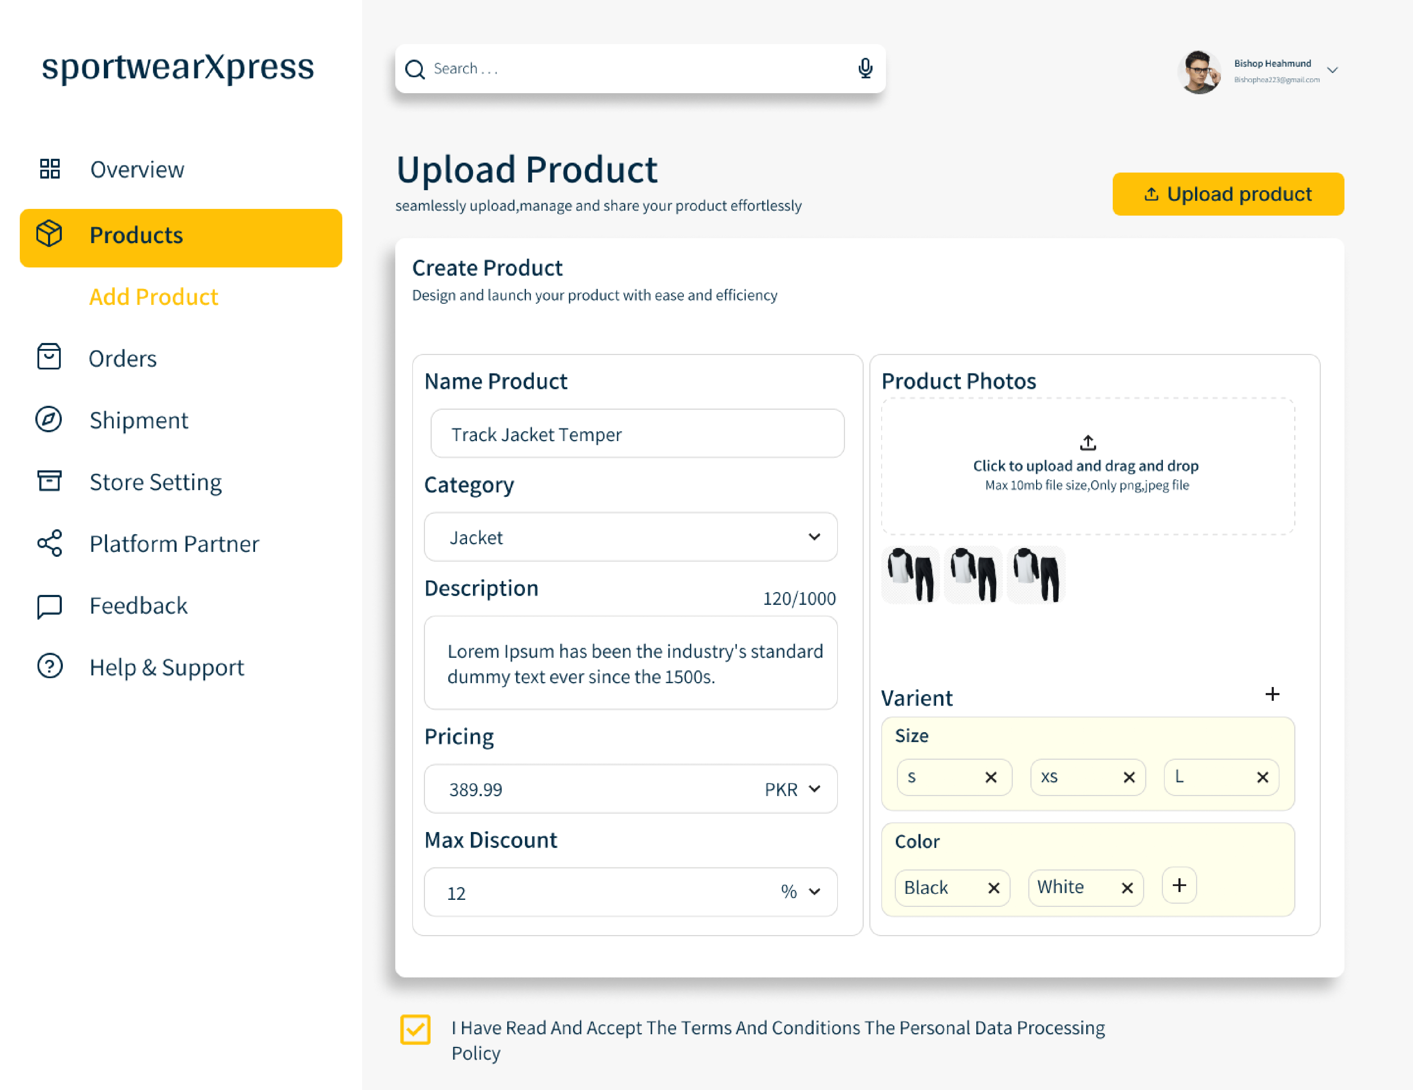

Screen #9: Upload Product

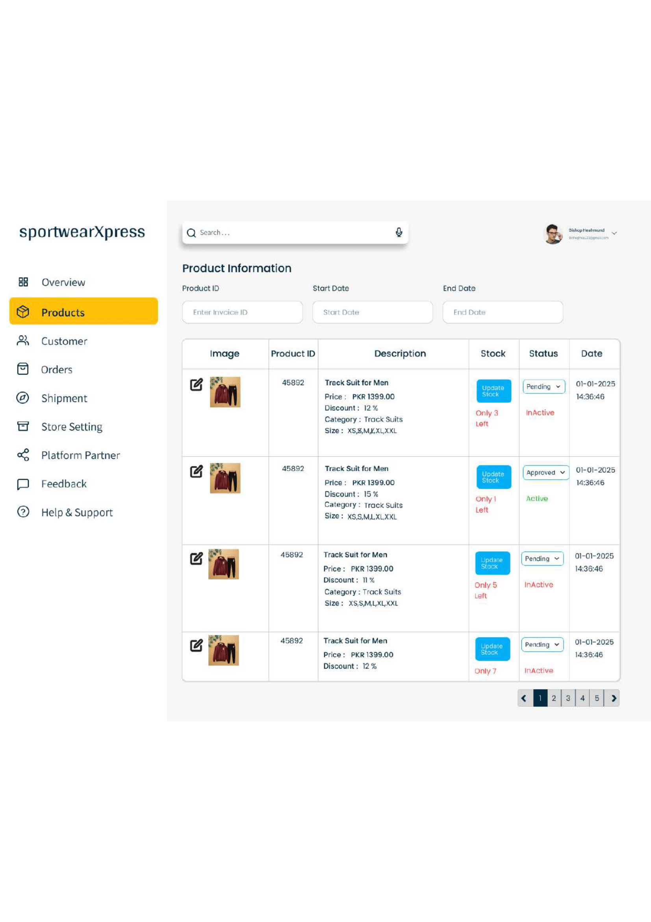

Screen #10: Product Information

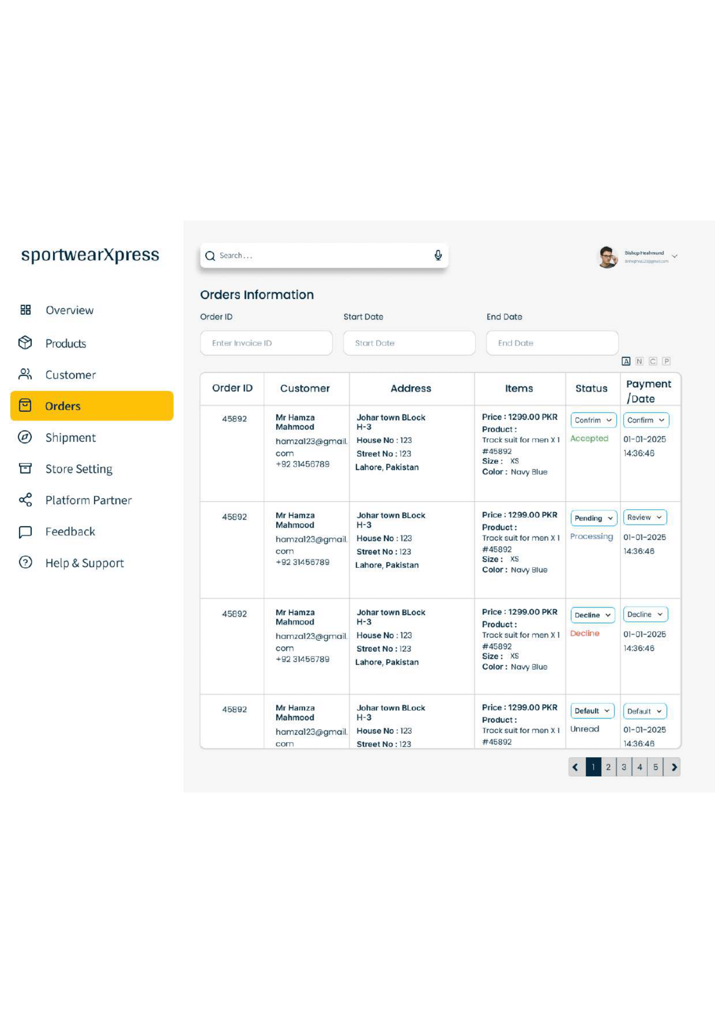

Screen #11: Order Information

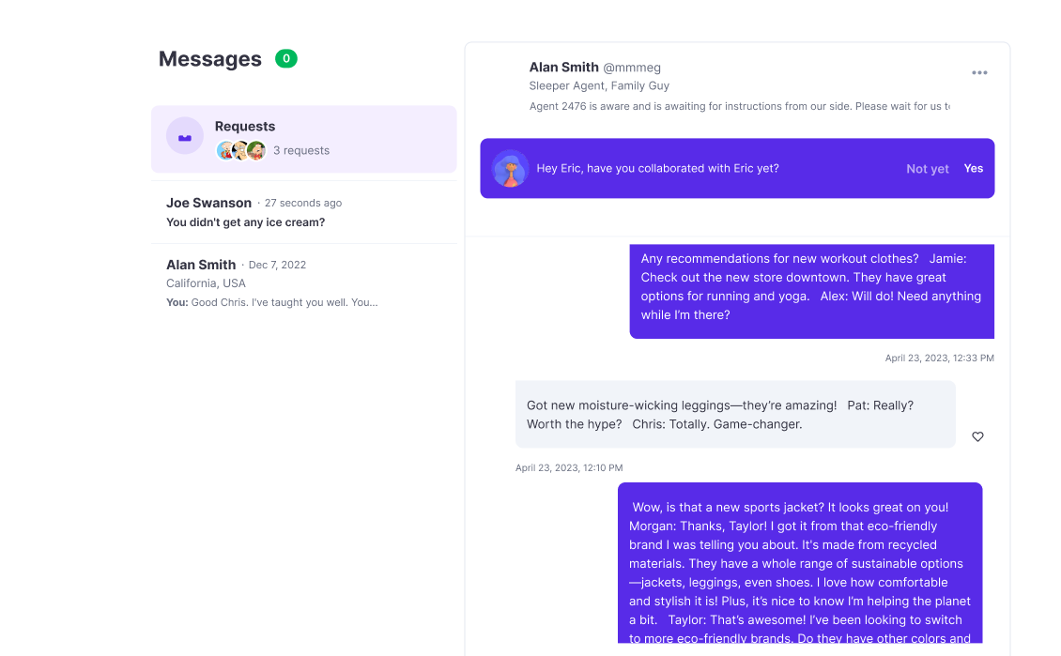

Screen #12: Messenger

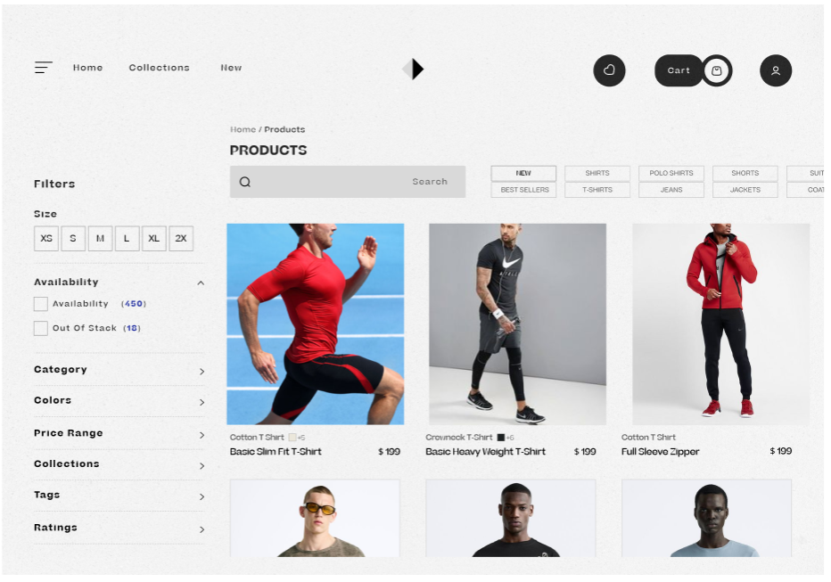

Screen #13: Products

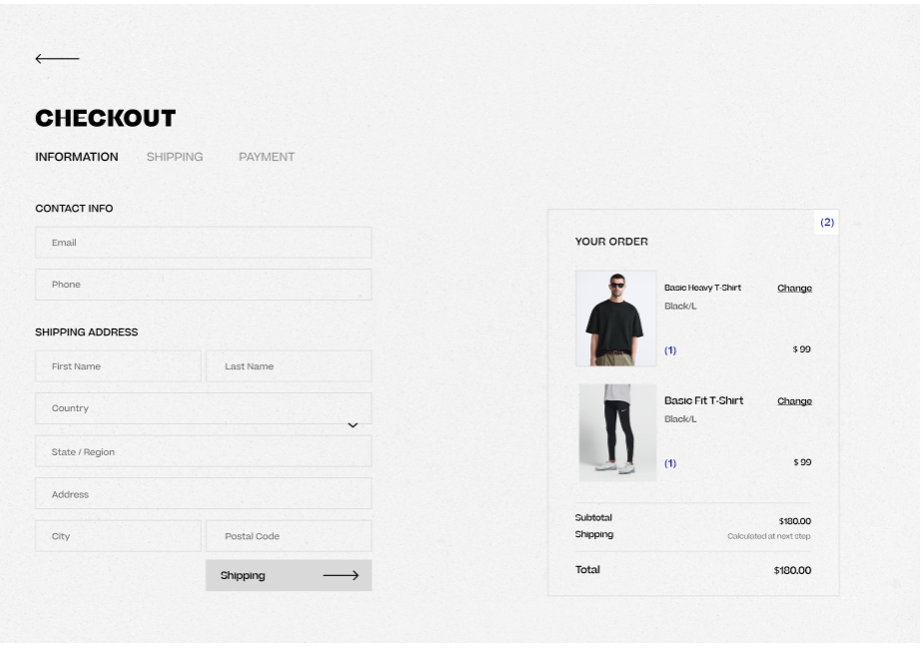

Screen #14: Checkout

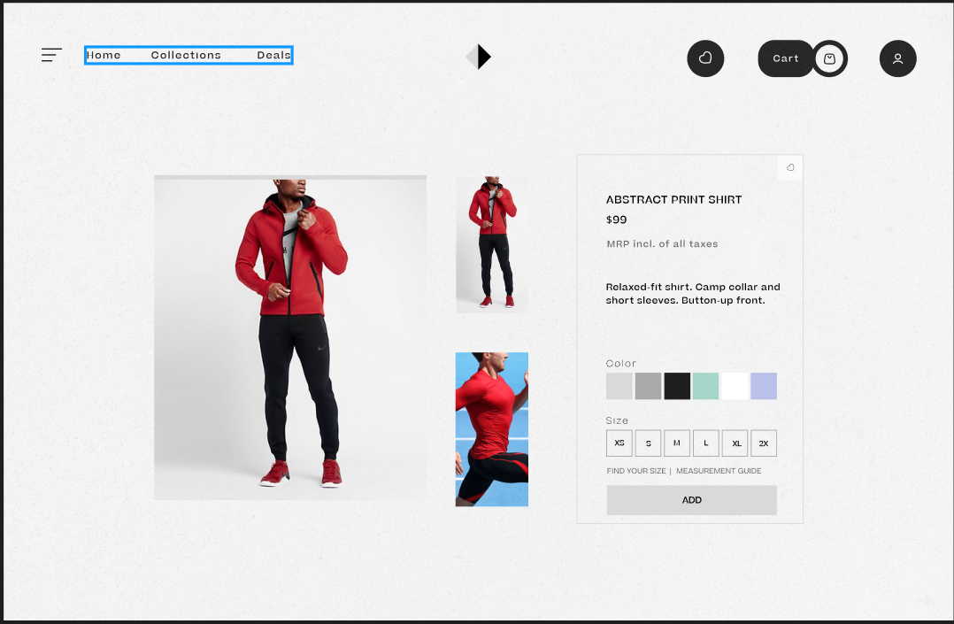

Screen #15: Checkout

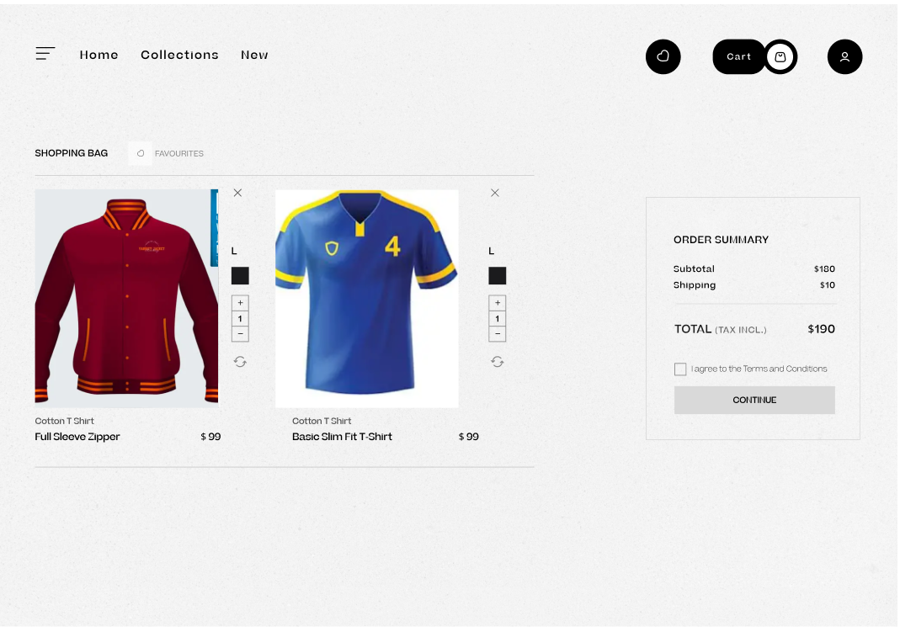

Screen #16: Checkout

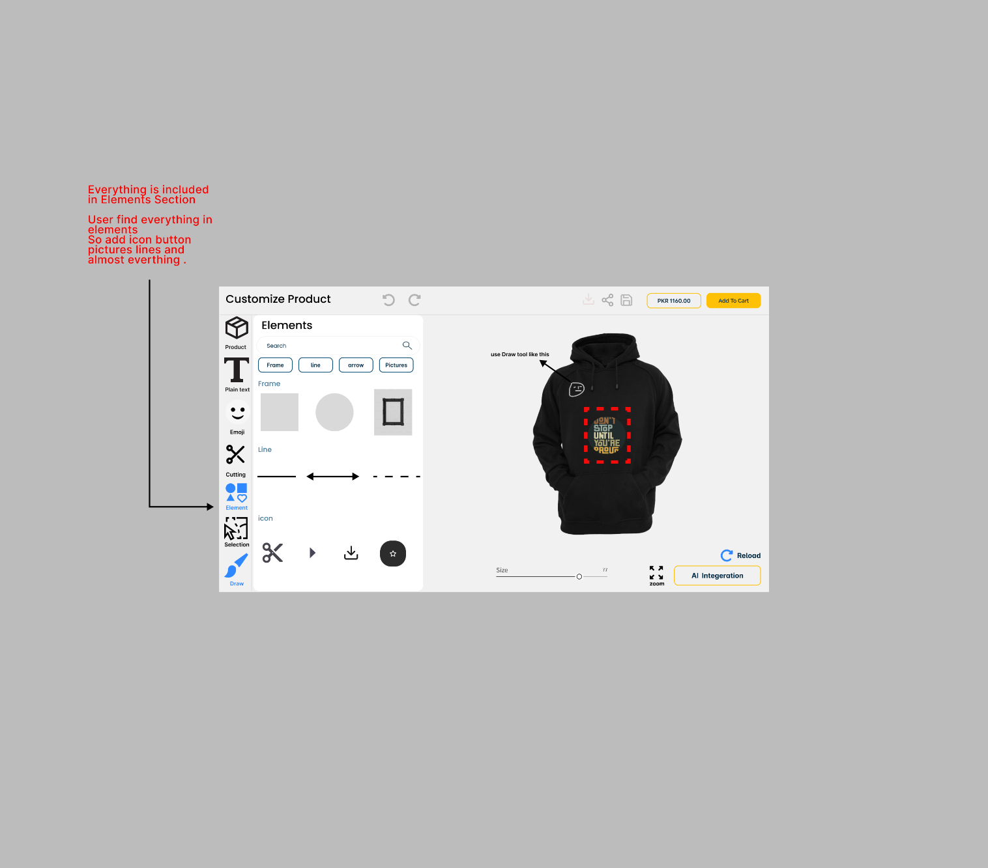

Screen #17: Logo Printing

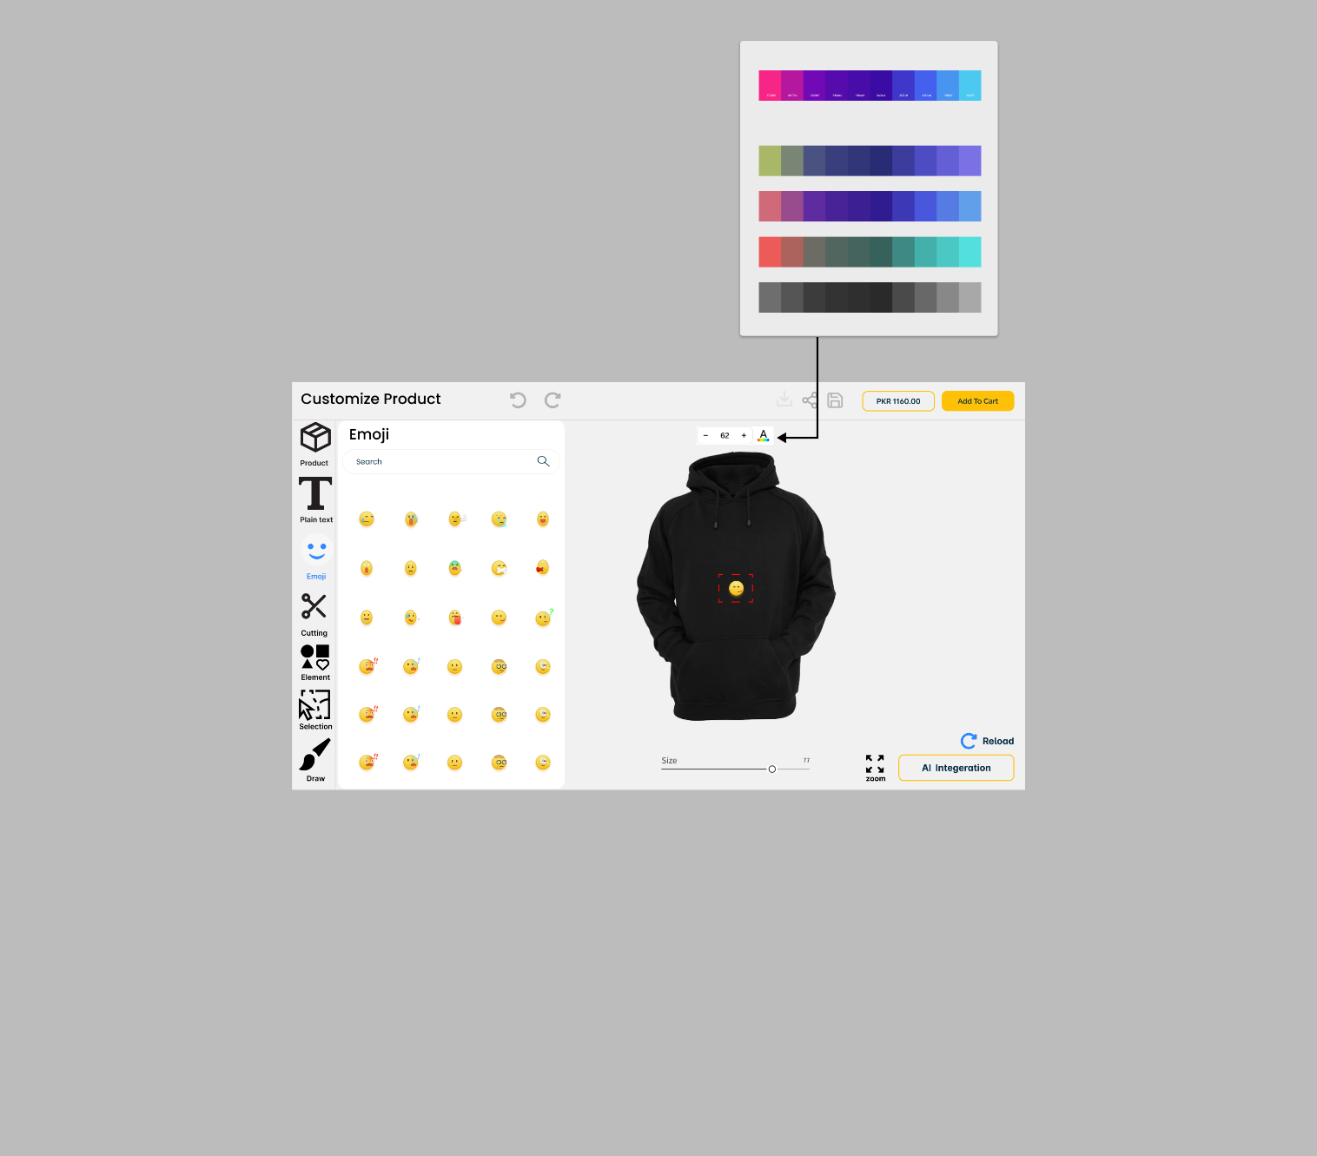

Screen #18: Customization

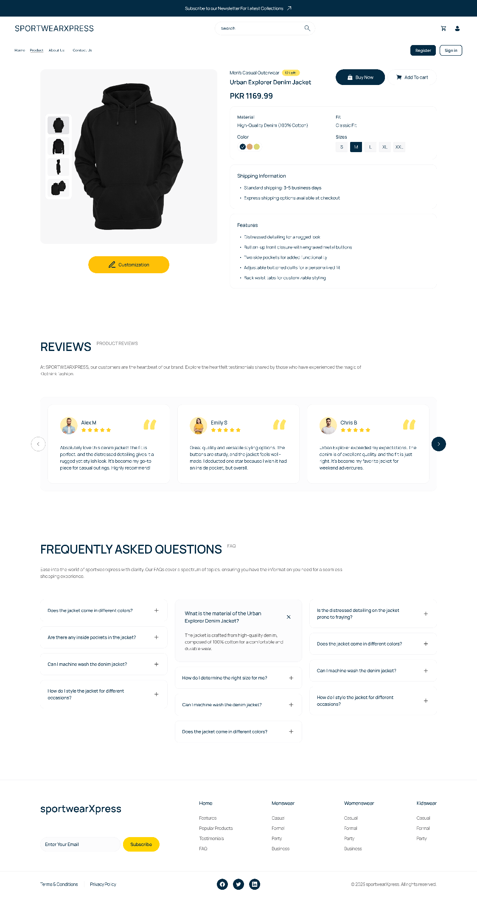

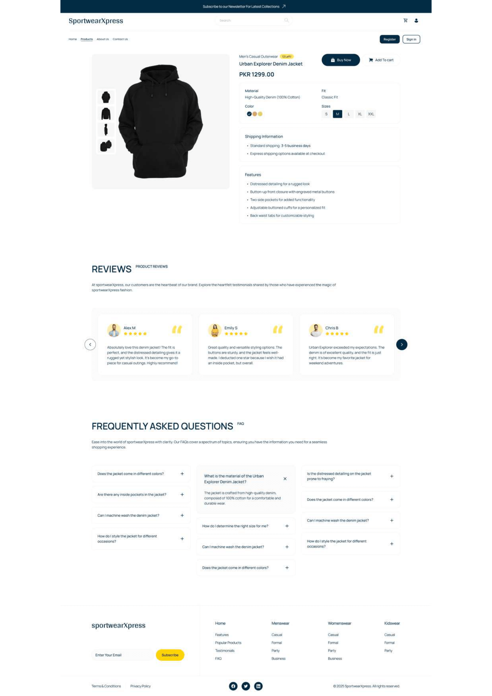

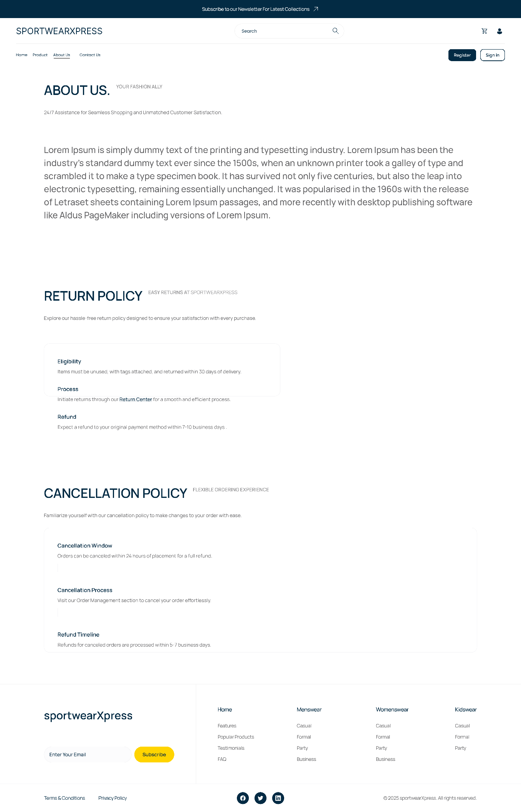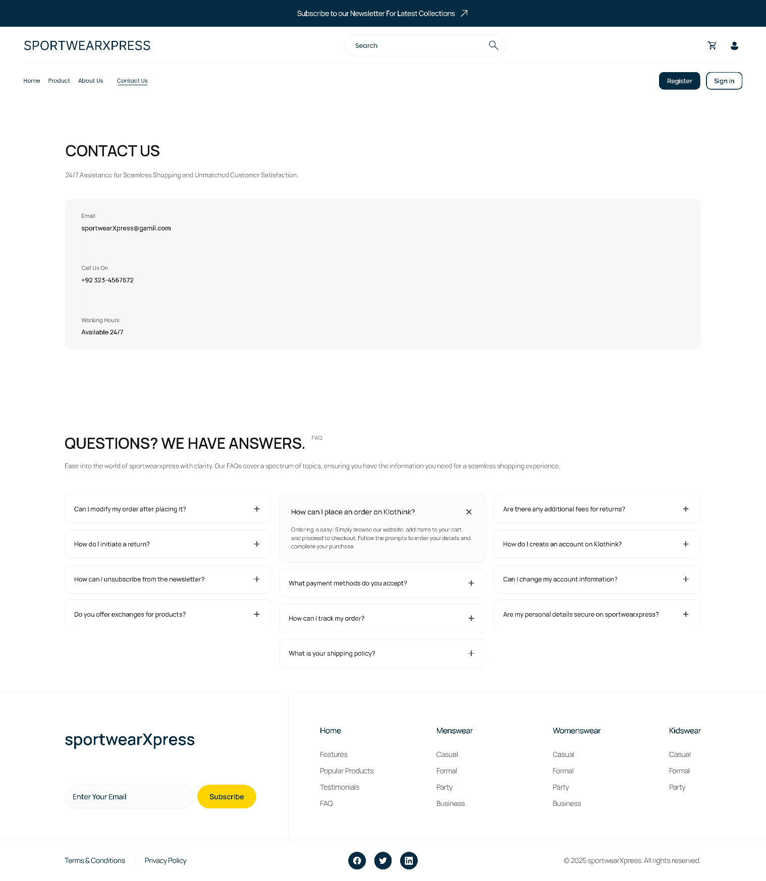

## 4.3 Additional Information

We used Figma for designing these interfaces.

# Other Design Details

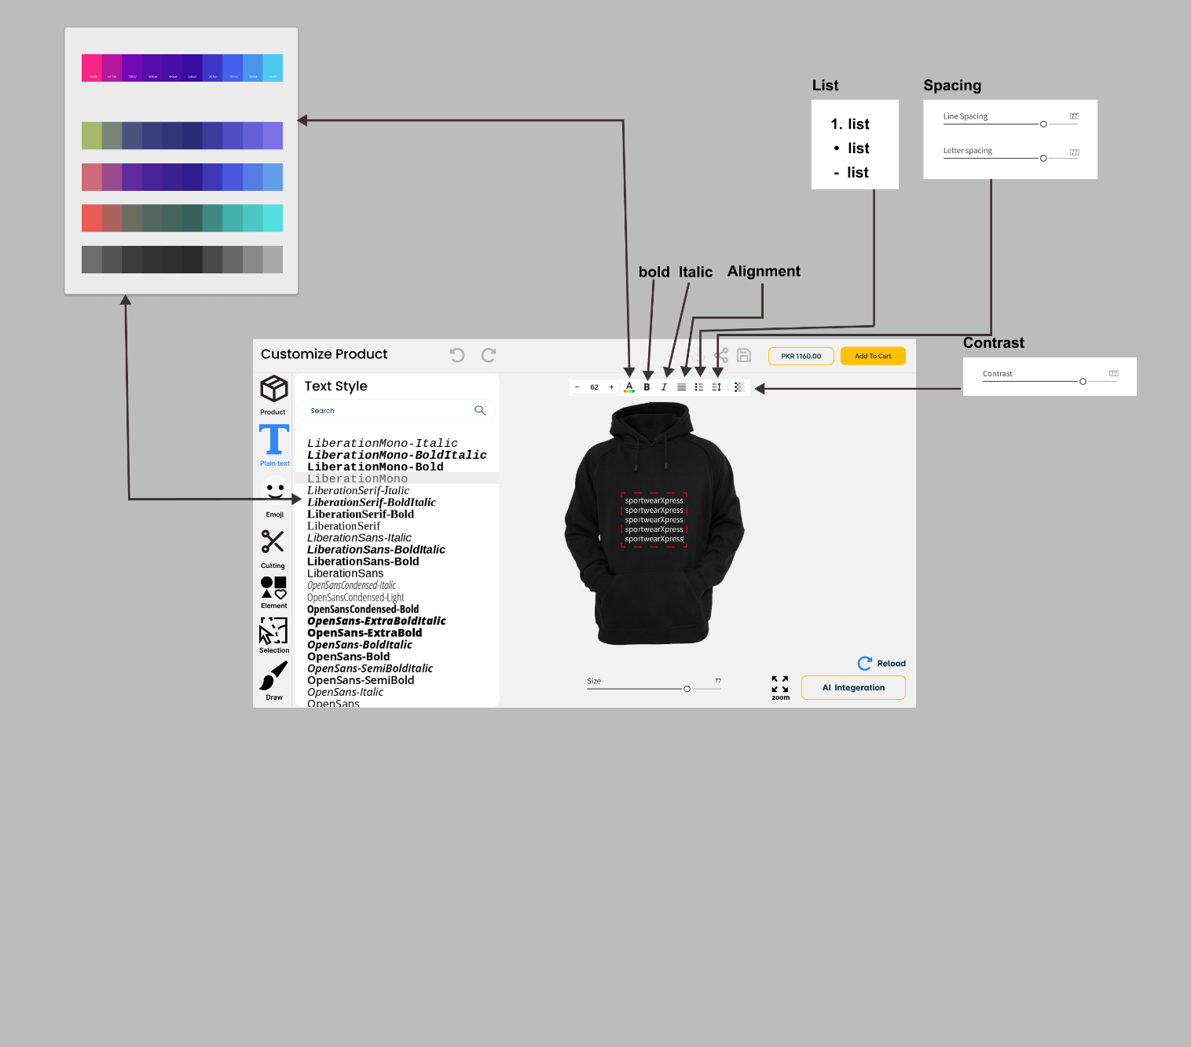

# Revised Project Plan

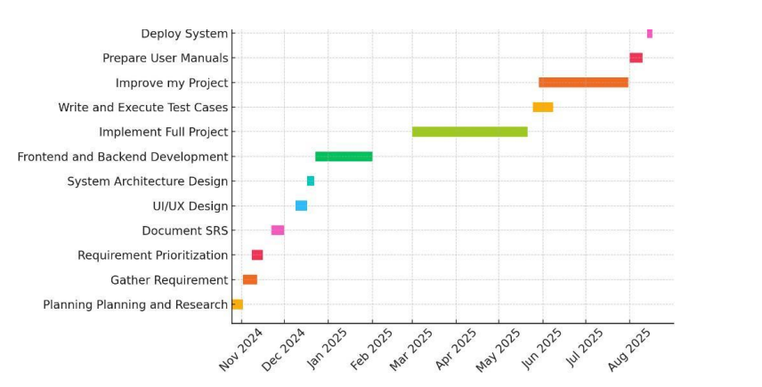

# References

*[1] Zazzle, “Zazzle - Customize Anything,” [Online]. Available: https://www.zazzle.com/. [Accessed: 26-*

*Nov-2024].*

*[2] Custom Ink, “Custom Ink - Custom T-shirts and More,” [Online]. Available:*

*https://www.customink.com/. [Accessed: 26-Nov-2024].*Appendix A: Glossary

|  |  |
| --- | --- |
| **Terms** | **Definition** |
| **AI** | Artificial Intelligence: The simulation of human intelligence processes by machines, especially computer systems. These include learning, reasoning, and self-correction. |
| **APIs** | Application Programming Interfaces: A set of definitions and protocols that allow different software systems to communicate with each other. |
| **Dynamic Pricing** | A pricing strategy where the price of a product or service can change dynamically based on factors such as demand, stock availability, or user-specific preferences. |
| **E-Commerce** | The buying and selling of goods and services through online platforms. SportswearXpress is an e-commerce platform for custom sportswear. |
| **Inventory Management** | A system for tracking stock levels, orders, sales, and deliveries to ensure adequate stock availability for seamless operations. |
| **Product Customization** | The process of allowing customers to personalize their products by selecting designs, colors, and other attributes using AI-powered customization tools. |
| **AI Assistance** | The feature in the system that uses machine learning models to provide users with recommendations or assist them in customizing products effectively. |
| **TensorFlow** | An open-source machine learning framework used in the AI Assistance module for building and deploying machine learning models to assist with customization. |
| **Product Database** | A centralized storage system for product details, including stock availability, customization options, and metadata used across the platform. |
| **SportswearXpress** | The name of the project, which is an AI-powered e-commerce platform offering customizable sportswear products with real-time pricing and seamless order tracking capabilities. |

Appendix B: IV & V Report

**(Independent verification & validation)**

**IV & V Resource**

Name Signature

|  |  |  |  |  |  |
| --- | --- | --- | --- | --- | --- |
| **S#** | **Defect Description** | **Origin Stage** | **Status** | **Fix Time** | |
| **Hours** | **Minutes** |
| 1 |  |  |  |  |  |
| 2 |  |  |  |  |  |
| 3 |  |  |  |  |  |
| … |  |  |  |  |  |

**Table 1: List of non-trivial defects**

This document has been adapted from the following:

1. Previous project templates at UCP
2. High-level Technical Design, Centers for Medicare & Medicaid Services. (www.cms.gov)